



PARS Reporter User Guide

- Introduction

PARS Reporter is a custom software application designed to simplify the process of managing and encoding the Program, Activity, Partner and associated data that is required to comply with CIDA’s PARS reporting specification.

PARS Reporter is an easy-to-use, yet powerful system that leads to accurate and error-free PARS up-load files.

The following features make PARS Reporter a valuable single collection point for your PARS reporting:

- Simple to understand user interface.
- Pre-loaded CIDA data for many Activity choice options. IE. Sector, Region, Country, Theme codes.
- Ability to set up a master list of Overseas Partners with appropriate contact information.
- Automated data error-checking prior to Export file creation.
- Data error location Go-to buttons to ease error correction.
- Data warnings located throughout the user interface to help users to capture accurate PARS compliant data.
- Flexible filename definition options.
- Ability to import legacy PARS data from CIDA.
- Ability to export multiple Activities in one PARS upload file.
- Upgradeable to client-server mode.
- Can be used in mixed Windows and/or Macintosh environments.
- Contribution and percentage allocation calculations are performed automatically.
- Enhanced Finance, Metrics and Milestone tracking capabilities.

Certain features available in the standard version of PARS Reporter are not available in PARS Reporter Lite. PARS Reporter Lite does not include the enhanced Finance, Metrics and Milestone screens, and certain Export functions are disabled. The ability to export the CIDA PARS file is enabled in PARS Reporter Lite. Buttons and screens that are disabled in PARS Reporter Lite will display an explanatory dialog when a user attempts to use then, or the function will not be visible. To upgrade from PARS Reporter Lite to the standard PARS Reporter version, contact Nufocus Inc.

PARS Reporter RBM introduced new functions for Results Based Management (RBM) analysis and reporting to the standard version of PARS Reporter. These features are discussed in the separate RBM Guide that is supplied to all purchasers of the PARS Reporter RBM upgrade. Contact Nufocus Inc. for further information.

- PARS Basics

The 2 fundamental units in PARS Reporter are Programs and Activities. PARS Reporter is designed to organize the relationship between a Program and it’s subordinate Activities, and allows the user to link Activities to the different Programs you operate. Also, PARS Reporter allows you to Extend Activities into subsequent years and manage the linkage of your Partners to your Activities. Best of all, PARS Reporter quickly prepares the PARS compliant load file that is required by CIDA on a regular basis.

- The Navigator

When you first start the PARS Reporter applications, you will see the Navigator Welcome screen:

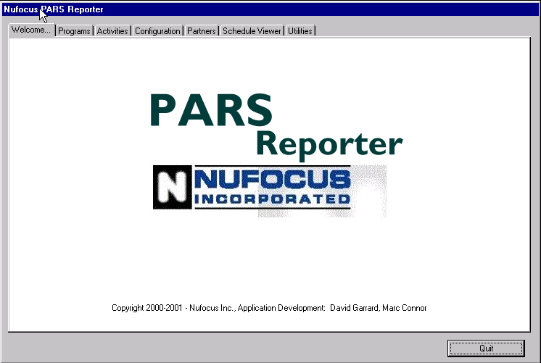

The Navigator Screen contains the Navigator Tab control and the Quit button. The Tab control is used to navigate the six Navigator Tab pages: Welcome…, Programs, Configuration, Partners, Schedule Viewer and Utilities. These are described in further detail below. Click on the Tabs along the top to move from page to page. Clicking the Quit button will exit the application.

  - Programs Tab

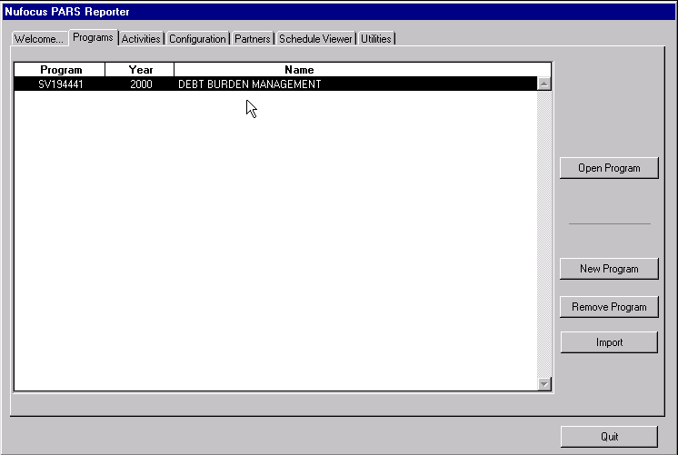

The Programs page contains a list of all programs currently in the system. Clicking on a column header of the list area (for instance the word “Program”) will sort the list in ascending alphabetical order by that column. Select a Program and click on Open Program to see the Program Information screen, which will be described later. To delete a program, select it in the list, and click Remove Program. Note that if one or more activities are linked to the removed Program, deleting that Program will also delete the associated Activities. To create a new Program, click New Program, and the New Program Screen will open.

You may also Import an existing PARS record on this screen by clicking the Import button. You will be prompted for a file name. This file must be in the PARS file format specified by CIDA. Attempts to import other files could lead to data corruption. Once you have entered the file name or chosen the file from your hard drive, you will be notified when the import is complete. Always make a backup of the data file prior to importing CIDA PARS Files.

Since Program Numbers must be unique, you will be informed if the imported Program has the same number as a Program already in PARS Reporter, and you will be given the option of renaming it, or skipping it. The same applies to activities – if you attempt to import an Activity already in PARS Reporter, you will have the option of either changing the name, skipping, or linking the existing Activity to the new Program.

    - The New Program Screen

New Programs are added using the New Program screen. All Programs need a Program Number, a Name and a Start and End Date. All four fields must be entered before clicking on the Save button. Some red warning text may appear on this dialog with advisories concerning required data in certain fields.

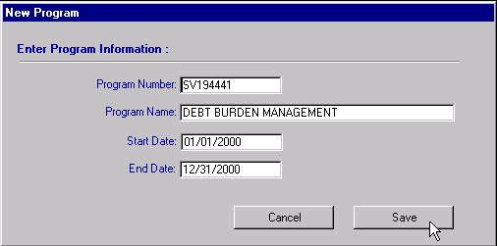

  - The Activity List Screen

The Activity List screen displays all Activities in PARS Reporter. New Activities are added using the Add Activity button. To view an existing Activity, select an Activity on the list and click on the Open Activity button. Section 4 describes the Activity Information screen.

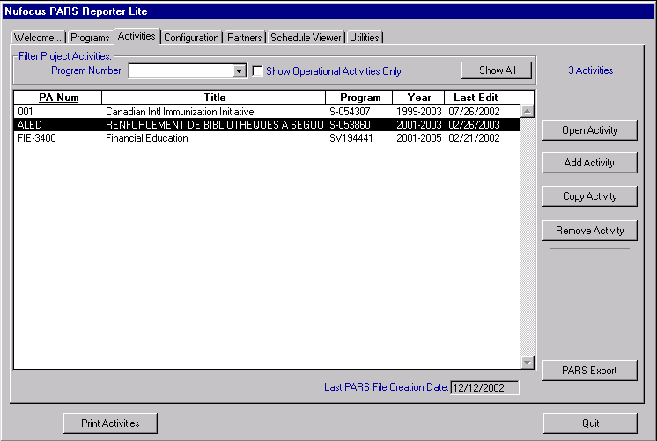

To extend an Activity, select an Activity from the list and click on the Add Activity button. You will be prompted to either Add a New Activity or Extend the selected Activity from the list. Extending simply clones the selected Activity completely and increments the Year on the new one. If you do not wish to create or extend an Activity, select Cancel.

By using the controls found in the “Filter Project Activities” block, the Activities listed on the screen can be filtered by either Program and/or Operational Status. Click on the Show All button to list all Activities in your PARS Reporter data file.

Click on the Print Activities button if you wish to print individual Activity information or a Activities Financial Contribution Listing. See section 4.10 for more details.

The PARS Export button enables you to generate a PARS File containing data from multiple Projects/Activities. To create a multiple Project/Activity PARS File simply click , shift-click and/or control-click on the Activities in the list until you have the desired selection for export. Note that you should Open each Activity and proceed to the Export page prior to creating a multiple Project/Activity PARS File. This is recommended so that you can individually test the readiness of each Project/Activity record’s data prior to attempting to create the PARS File.

Please refer to the IMPORTANT NOTE found in section 4.9 regarding sending files to CIDA.

  - Configuration Tab

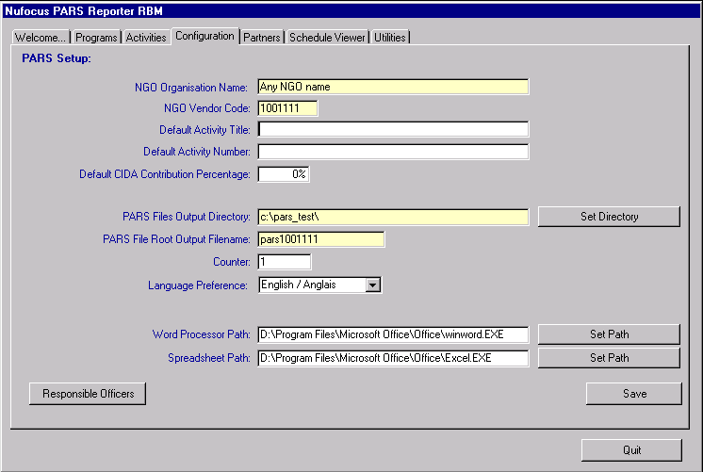

The Configuration Tab displays the PARS Reporter system settings. When you create a new Activity, certain fields will be automatically populated with the default data defined on this page.

Note that the yellow fields are required fields, whereas the white one are optional

Enter your Partner Vendor Code.

If you wish to pre-title your new activities, you can enter a default name in the Default Partner Activity Title, and Default Partner Activity Number in the appropriate entry fields.

Enter a Default CIDA Contribution Percentage if desired. This is used to calculate a contribution value on the Activity Contribution page, based on the amounts of Disbursements entered in the system. (The Disbursements tab is not available in PARS Reporter Lite.)

Please refer to your CIDA documentation if you are unaware of the correct entries. Or further sections in this manual: (Activity – Information and Contribution sections)

The PARS Files Output Directory is the place on your hard drive where you would like the exported PARS files to be stored. Use the Set Directory button to select an existing directory.

According to CIDA’s naming conventions, the name of a PARS output file is:
- The word “pars”
- Followed by your organization’s Partner Code
- Followed by an underscore
- Followed by the current calendar year
- Followed by a five digit file number
- Followed by the extension “.dat”

To comply with CIDA file naming conventions, the PARS File Output Filename should be “pars”, followed by your Partner Vendor Code. When exporting an Activity, PARS Reporter automatically creates the filename by concatenating items 1 through 6. The five-digit file number (item 5) is automatically incremented by the system, and the current value is displayed here as Counter. You may reset this at any time. Note that when it comes time to perform your export, you will have the option of changing the Output Directory and Filename on the individual Project/Activity.

Note that CIDA requires that all PARS Files that are submitted arrive in numerical order. This means that the final name of the file that is sent to CIDA MUST follow the previously submitted PARS File. Use the Counter field to increment or decrement the counter value if necessary.

Note also that if a PARS .dat file is rejected by CIDA, you will need to resubmit the corrected file using the same file name as the rejected one. You can decrement the Counter value and then click Save Edits in the Configuration tab to reset the counter value.

Note also that you can manually “rename/renumber” the PARS .dat file using the Operating System’s file rename function once the file is created in your Output Directory.

Enter the path to your local Word Processor and Spreadsheet applications if you wish to auto-launch these applications after exporting certain reports from PARS Reporter.

Note that if you do not click Save, your Configuration changes will be lost.

  - Partners Tab

The Partners Tab is used to maintain your master list of Partners, and their contact information.

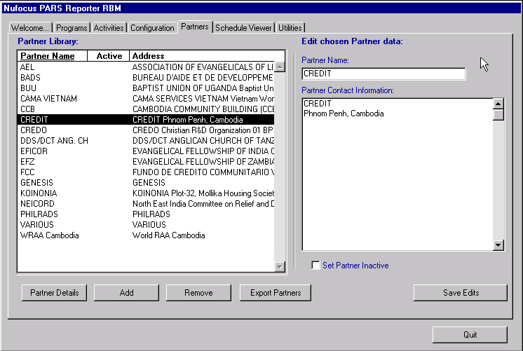

To add a new partner, click Add. This will create a new entry in the list – “New Partner” followed by a unique number. Simply edit the data to suit your needs, and click Save Edits.

To change a partner’s information, select the partner’s name in the list on the left. That partner’s name and contact information will appear in the text boxes to the right. You may edit the Partner Name, Partner Contact Information and Part Inactive status on this screen. Click on Save Edits to save the new information. If you do not click Save Edits, the changes will not be saved.

To remove a Partner from the Partner choice list that appears when your wish to add a Partner to an Activity, turn on the Set Partner Inactive checkbox.

To delete a Partner, select the partner’s name from the list and click Remove. (In most cases, it is recommended to use the Set Partner Inactive checkbox instead of removing Partners.) Note that you will not be able to delete a Partner from this list if they have already been added to a Project/Activity. In this case, you would have to go into each Project/Activity that uses this Partner and remove the linkage to this Partner prior to removing them from PARS Reporter entirely.

Further Partner Information such as Partner E-mail Address, Partner Details Text and Partner Chronology Text is available by clicking on the Partner Details button.

Click on the Export Partners button to view a word processor document that lists all your partners and their particulars including activities that they are partnered on.

These Partners will be displayed in the list of available Overseas Partners that can be associated with a Project/Activity. You will see more about this in the Activity Information section.
  - Schedule Viewer Tab

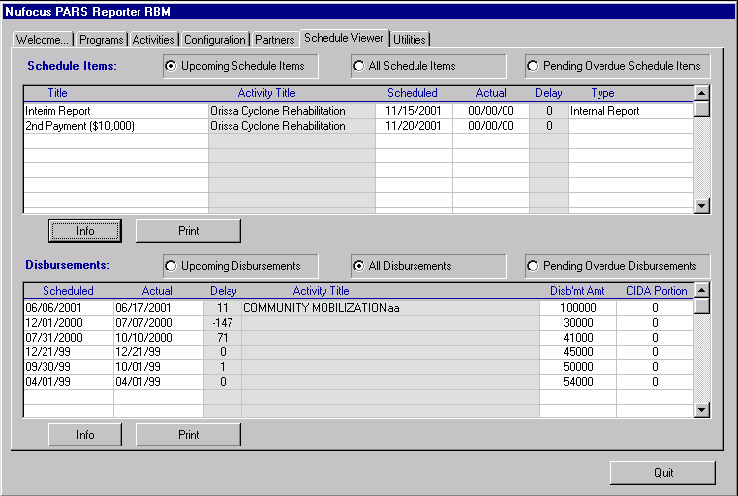

The Schedule Viewer Tab has been added to the Navigator to allow you to view all of the Schedule items on all your Activities on a single screen. Choose the desired type of view using the buttons at the top of the screen.

Upcoming Schedule Items include all items that are scheduled on Active Activities that are scheduled to occur within the next 30 days.

Pending Overdue Schedule Items lists are those scheduled items that were scheduled to occur in the past, but have not occurred yet.

Refer to the Activity – Schedule Tab section to learn how to add Schedule items to your Activities.

Note: This screen is not available on PARS Reporter Lite.

  - Utilities Tab

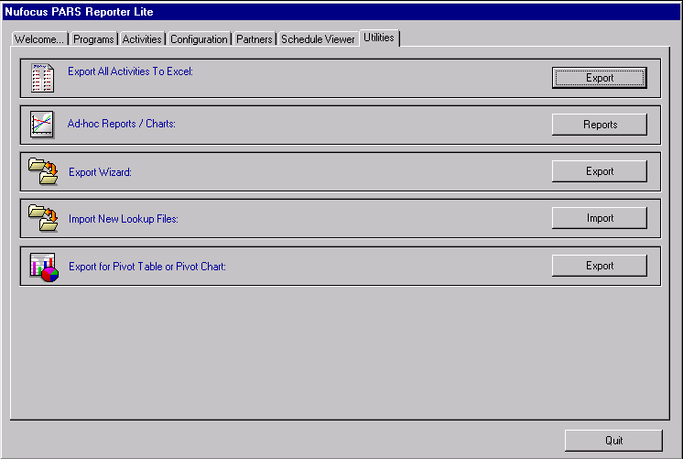

The Utilities Tab contains several tools to access the data in PARS Reporter:

The Export All Activities To Excel export utility creates a data dump in Microsoft Excel format for you to see all data in the PARS Reporter system. Flexible graphing and allocation analysis can be performed within the Excel spreadsheet. Use this export when you wish to report on Project/Activity data from PARS Reporter. Note: This option is not available on PARS Reporter Lite.

The Ad-hoc Reports / Charts option displays a PARS Data Wizard page and allows you to create and save templates for custom reporting of PARS data across all the Projects/Activities in PARS Reporter.

Note: This option is not available on PARS Reporter Lite.

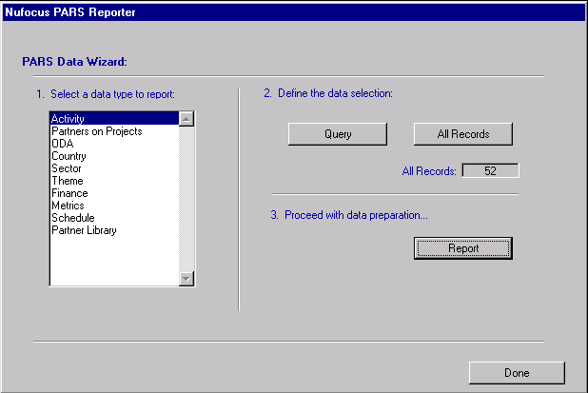
  - First, select the data type from the scroll area on the left.
  - Click on the Query button to find records of a certain type, or click on the All Records button to list all the records in PARS Reporter.
  - Click on the Report button to display the template editor. Drag and drop the desired fields into the report template. See below.

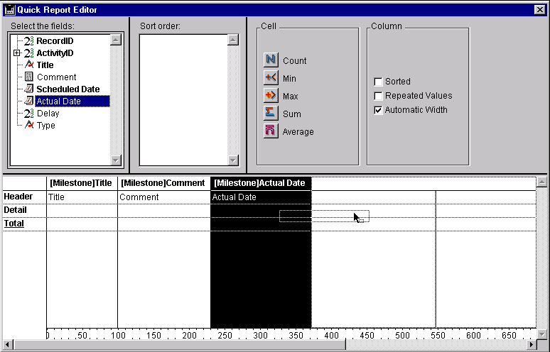

Once a template is created, it can be saved and re-loaded using the File… Save As… and File… Open… menu items respectively. Reports can be printed or exported.

To export to Excel format choose File… Print Destination… Disk File, and then Choose File… Print. Name the file with a .xls extension.

The Export Wizard option also allows you to create and save templates for custom exporting of PARS data across all the Projects/Activities in PARS Reporter. This option is the recommended approach if you wish to export data from the associated tables such as Finance, Partner, Metrics, Schedule. Note: This option is not available on PARS Reporter Lite.

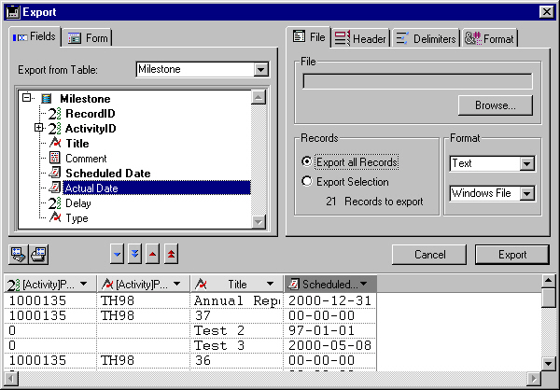

To export data using the Export Wizard:

1) On the Export dialog, where it says Export From Table on the left side, click on the popup and choose the desired table.

2) Then click on the Export all Records choice on the right-hand side of the screen.

3) On the left hand side again, click on the little blue icon below the list of fields in the chosen table that has two arrows down on it. Data should appear below.

4) If you do not want certain columns, click your mouse on the column in the data below, and click once on the icon with the single red arrow up.

5) Click on the Browse button and type a file name and save it to the desktop or somewhere you prefer.

6) Click on the Export button. The data will be exported. Open the data file using a spreadsheet package such as Microsoft Excel.

The Import New Lookup Files option lets to import updated Lookup files into PARS Reporter. Periodically, CIDA may amend the lists that contain the ODA, Sector, Country, and Theme information. To update your copy of PARS Reporter, the new list files must be placed in the Lookup_Data folder, which is found in the PARS Reporter directory on your computer. A complete selection of files must be located in this directory. For single user setups, the files are imported by simply clicking on the Import associated button. For client-server installations, a directory select dialog lets your locate the Lookup_Data directory on your computer. (The original files will be found on your 4D Server host computer.) Please contact Nufocus Inc. to receive your new lookup files.

The Export for Pivot Table or Pivot Chart option allows you to export a special file dedicated to creating Pivot Tables or Pivot Charts in spreadsheet application such as Microsoft Excel. Pivot Charts allow you to view PARS Reporter data in complex relationships such as CIDA Cash by Sector and by Country simultaneously. Note: This option is only available on PARS Reporter enhanced versions.

- The Activity Information Screen

The Activity Information Screen is displayed when an Activity is opened from the Navigator Activities Tab page. To open an Activity, double-click on it in the listing, or select an Activity and click the Open Activity button.

Once an Activity is opened, edits to Activity Information are done on the various tabs of this screen. Similar to the main Navigator screen, the Activity Information Screen features a tab control which you can use click on to move from page to page.

Each of the first eight pages corresponds to a PARS record type. Page one contains the “Type 10” information. Items with a yellow background are mandatory, and you will be unable to export if they are not filled in.

The ninth tab, Internal Comments is a free-form text field that allows you to enter any other internal information that you wish to track concerning the Activity. This data does not get transmitted to CIDA.

The tenth tab, is the Export control page that allows you to error-check and subsequently create the PARS File on your computer hard drive. Note that PARS Reporter does not actually send the file to CIDA, it only prepares it for transmission. Other FTP software is required to make the actual data transmission to CIDA. Refer to Section 5.0 for further details. Contact Nufocus Inc. at support@nufocusinc.com if you require help in this area.

Tabs 11 through 13 allow you to track enhanced Activity information in PARS Reporter. See below.

  - The Activity Tab

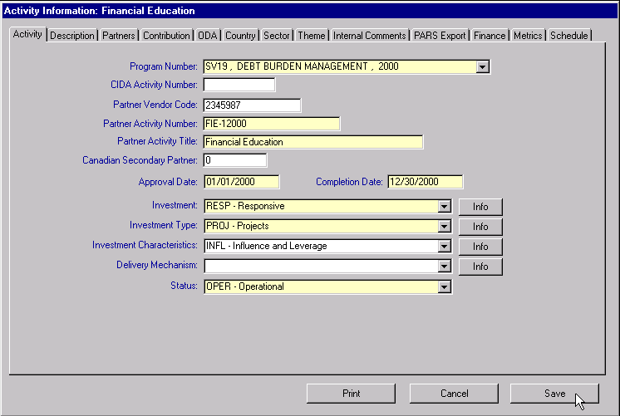

The Activity Tab contains the basic information about the Activity: Program Number, Name, Numbers, Partner relationships, Activity dates, and various Investment, Delivery and Status settings. Note that the yellow fields must be entered before a PARS export file can be created in PARS Reporter.

When you first open a new Activity, you will notice than many fields will be set to the defaults that you specified under the Configuration Tab on the Navigator Screen.

The CIDA Activity Number is supplied by CIDA to you. It can remain blank on the initial PARS file submission. Please update this field upon reception of the number from CIDA.

Clicking on the down arrow next to certain fields will produce a drop-down box from which you may select various items. These drop-downs have been populated with the latest CIDA standard choices for your convenience.

Additional Information describing the Investment choices and the Delivery Mechanism choice can be viewed by clicking on the Info button to the right of the choice options. Note that a Closed Activity can not be sent to CIDA.

  - The Description Tab

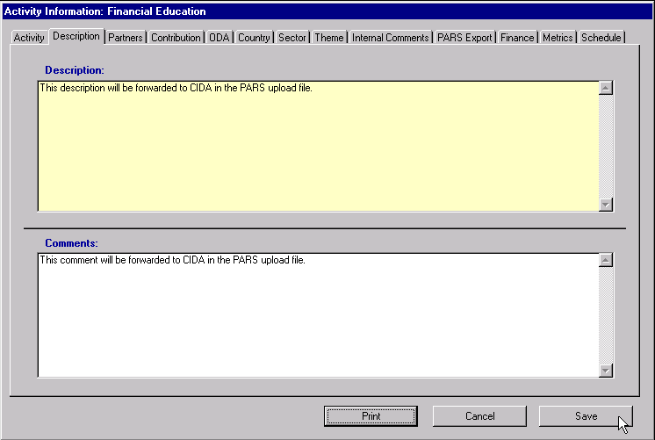

This page contains two scrollable text fields for the Activity Description and Activity Comments. These correspond to Type 20 and 25 in the PARS export file. You must enter a Description prior to export of the PARS file for CIDA.

  - The Partners Tab

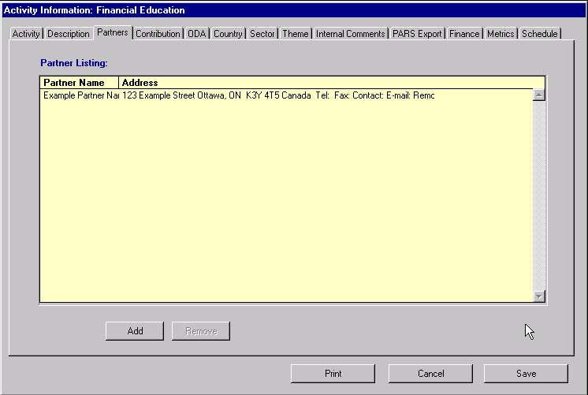

The Partner Tab contains the names of the Overseas Partners for this Activity. This corresponds to the Type 30 data in the PARS specification. To remove a Partner, select it in the list and click Remove.

To add a Partner, click Add. This will display a list of all of the OS Partners in PARS Reporter (as defined by you under the Partners Tab in the Navigator). To select a Partner, either double-click on the name, or click on the name and click OK.

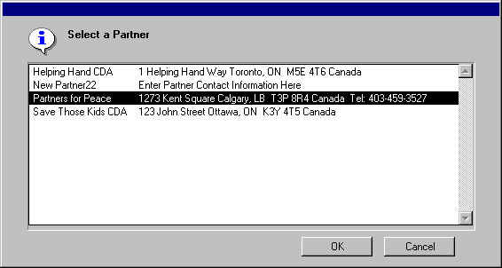

  - The Contribution Tab

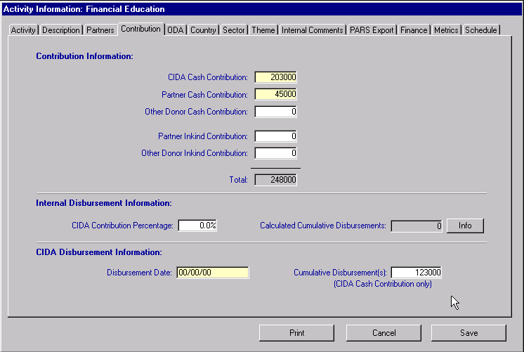

The Contribution Tab contains the basic financial information for the Activity. Changing any of the enterable Contribution amounts will cause the Total to be recalculated. As Disbursements occur, enter the amount and Date in the CIDA Disbursement Information fields.

Note that the total Cumulative Disbursement(s) amount (bottom right of screen) must not exceed the CIDA Cash Contribution figure. If a Cumulative Disbursement amount is entered, then a valid Disbursement Date is required. Periodically, red warning text may appear in the bottom right hand corner of the screen advising you of date or dollar amount discrepancies.

You can use the Internal Disbursement Information section to help calculate the correct Cumulative Disbursement(s). The CIDA Contribution Percentage value is an internal value only that is used to generate a Calculated Cumulative Disbursement amount based on the information tracked in the Finance Tab. Click on the Info button for more information about this feature. Note that the data in the Finance Tab (and Metrics and Schedule Tabs) are not forwarded to CIDA.

  - The ODA Priority Tab

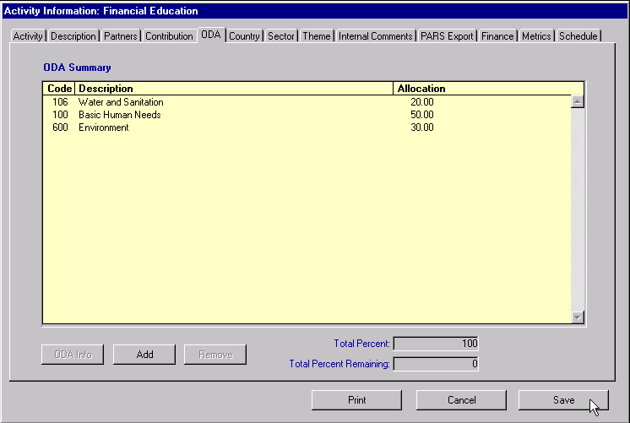

The ODA Tab is used to define the ODA Priority Allocations for the Activity. Priorities are added and removed in the same way as Partners, with the same kind of choice list:

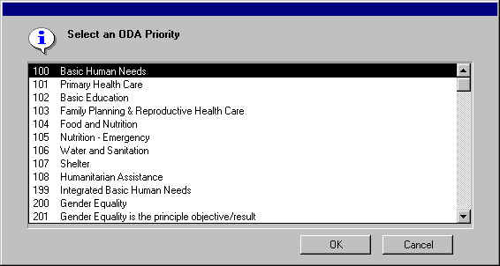

Once an ODA Priority has been added, you can adjust the allocation by double-clicking on the number in the Allocation column. When the number is changed, and you press tab or enter, or click out of the cell, the Total Percent and Total Percent Remaining numbers will be recalculated. The Total Percent allocation must equal 100% before the export can be performed.

  - The Country and Sector Tabs

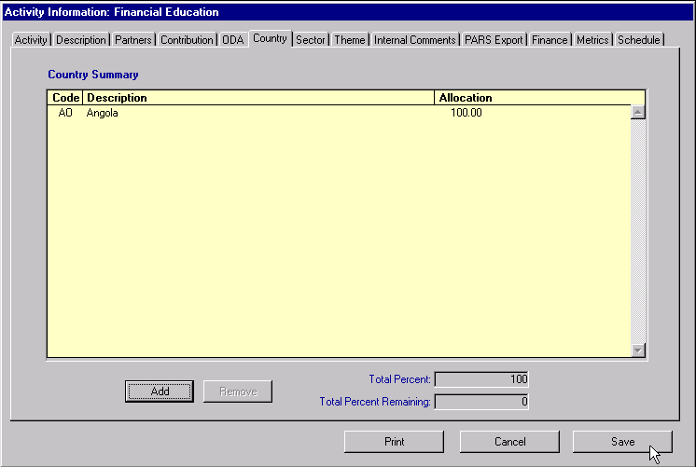

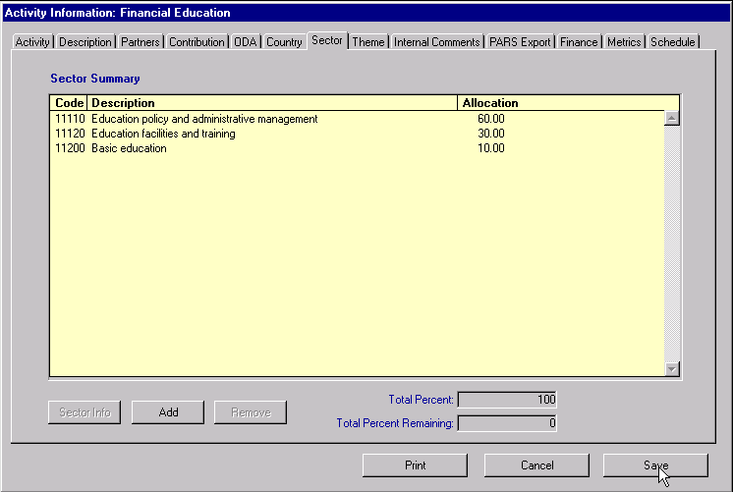

These tabs are used to set the Allocations for Country and Sector respectively. Similar to the ODA Summary Tab, Countries and Sectors can be added and removed using the appropriate buttons and Allocations can be edited by double-clicking, and then typing the correct percentage in the Allocation column. Remember to Save your edits.

  - The Theme Tab

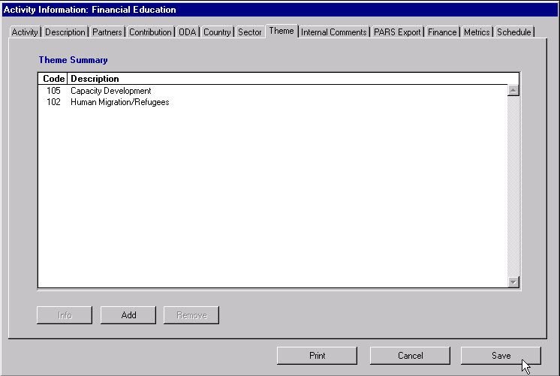

The Theme Summary Tab allows you to associate multiple Themes to an Activity. Use the Add and Remove buttons to edit the contents of the list of Themes.

  - The Internal Comments Tab

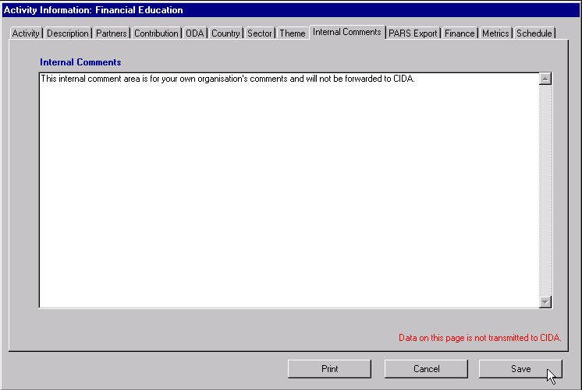

The Internal Comments Tab allows you to collect internal comments about an Activity. These comments will not be exported out of PARS Reporter in the CIDA PARS file.
  - The Export Tab

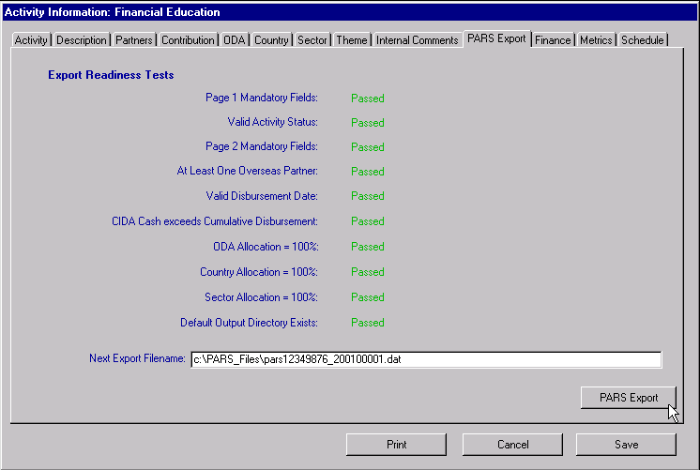

The Export Tab contains the data completeness tests and export information required when you are ready to perform the export from PARS Reporter to an output file. When displaying this tab, PARS Reporter automatically tests your Activity to make sure it is valid and complete relative to CIDA’s PARS specification. The following criteria must hold for an Activity to be exported to a PARS compliant file:

- The fields marked as mandatory (i.e. yellow background) must be filled in on the various Activity tab pages.
- There must be at least one Overseas Partner on the Partner Tab page.
- Each of the Total Allocations (ODA Tab, Country Tab, and Sector Tab) must equal 100%.
- A directory must exist on your hard drive in the location specified in the Output Directory field on the Navigator Configuration Tab.

If these tests pass, the Export button will be active. The Export Filename is partially determined by the default Output Directory and Output Filename set in the Configuration Tab on the Navigator Screen. PARS Reporter adds the calendar year and the Counter. This field is editable, so you can change the Export Filename as you wish.

If any of the tests fail, the screen will look similar to the following figure:

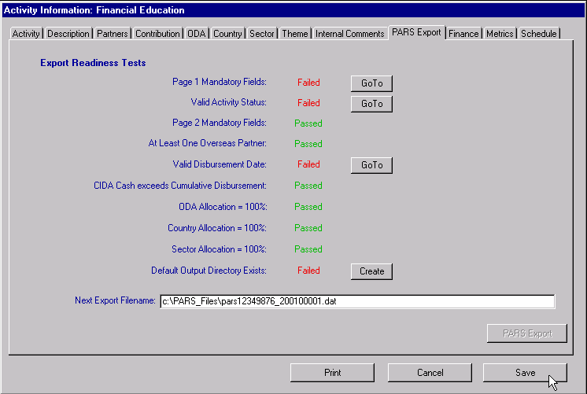

The Export button will be dimmed, and you will be unable to export. The Go To buttons allow you to go directly to the page on the Activity Information screen that contains the invalid or missing data. Click on these buttons to revert to the correct tab page and make the required correction. Then click on the Export Tab again to view the Export Readiness.

Once you are happy with your data, and all of the tests pass, return to the Export Tab. You can then export the Activity to a PARS compliant file if you want to create a PARS File for a single activity. Once you click on the Export button, the file will be created, and a dialog will inform you that the export has been completed. The five-digit number that comprises the last five characters of the filename will increment in readiness for your next export. Look for your PARS file in the directory specified in the Export Filename path. Note that CIDA prefers that PARS files are submitted with multiple activities instead of many single activity PARS files.

Important Note: PARS Reporter does NOT send the PARS file to CIDA as part of the Export process. Please refer to Section 5.0 for further information regarding sending your PARS .DAT Files to CIDA.

Remember to Save your changes once you have made edits in the Activity Information screen. If you click on the Cancel button, then all edits will be lost.

  - Activity Printing
The Print Activities button at the base of the Activity Information screen allows you to print a summary report of all the information about the Activity. To print the report, click on the Print Activities button, select the Activity Detail Report option, choose your printer settings, and then click OK to proceed. These printouts can be very valuable hard copy records of your PARS data.

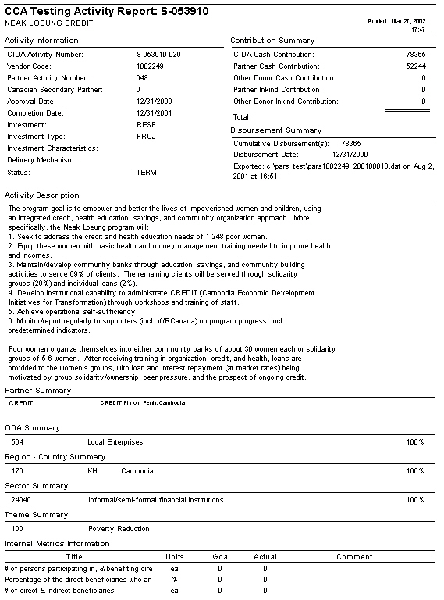

A Financial Listing Option is also available from the Print Activities button. This prints a listing of all contribution information for a list of Activities.

  - Internal Financial Data
Enhanced Financial data can be collected on Projects/Activities using PARS Reporter. The Finance Tab allows you to enter and monitor Financial data on individual Projects/Activities.

Click on the various fields to enter the Year, Quarter, Budget, Actual, Scheduled Disbursement, Actual Disbursement and Disbursement Amount. To add additional text data about a Finance item, you can select the item and then click on the Info button.

This data does not get sent to CIDA. On the Navigator Utilities Page, this data can be exported for other purposes by choosing the Export Wizard or the Activity Related Exports options.

Note: This screen is not available on PARS Reporter Lite.

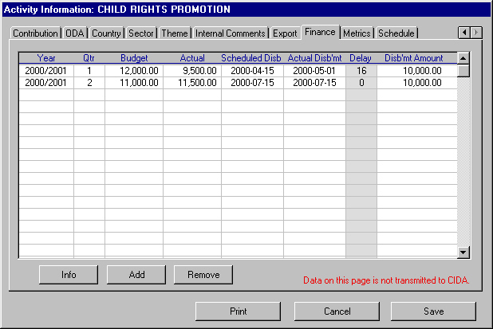

  - Internal Metrics Data
Enhanced Metrics data can be collected on Projects/Activities using PARS Reporter. The Metrics Tab allows you to enter and monitor budget line item data on individual Projects/Activities.

Click on the various fields to enter the Title, Units, Goal, Actual, and Comments. To add additional text data about a Metrics item, you can select the item and then click on the Info button.

This data does not get sent to CIDA. On the Navigator Utilities Page, this data can be exported for other purposes by choosing the Export Wizard or the Activity Related Exports options.

Note: This screen is not available on PARS Reporter Lite.
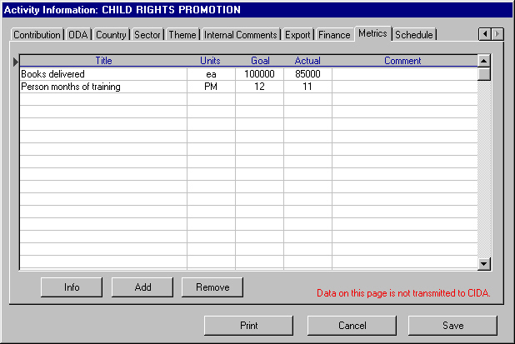

  - Internal Schedule Data
Enhanced Schedule data can be collected on Projects/Activities using PARS Reporter. The Schedule Tab allows you to enter and monitor schedule items on individual Projects/Activities.

To change the data in the Type column, double-click on it and choose the best choice: Project Milestone, Internal Report, External Report, Keyword, or enter your own type description.

To add additional text data about a Schedule item, you can select the item and then click on the Info button.

This data does not get sent to CIDA. On the Navigator Utilities Page, this data can be exported for other purposes by choosing the Export Wizard or the Activity Related Exports options.

Note: This screen is not available on PARS Reporter Lite.

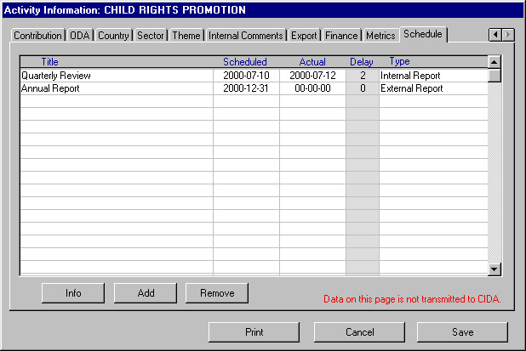

- File Transfer to CIDA

PARS Reporter does NOT send the PARS file to CIDA as part of the Export process.

For information concerning the process of sending PARS files to CIDA, please review the PARS file upload instructions provided by CIDA or contact CIDA directly if further information is required. You will need a ftp address, a user name and a password prior to connecting to the PARS FTP upload site. This information is found in the PARS documentation supplied to you by CIDA.
The PARS File must be sent separately to CIDA using File Transfer Protocol (FTP) software. A simple FTP client software package is all that is required to forward the file. Many shareware FTP products are available on the Internet. Examples are “CuteFTP”, “WS_FTP”.

Nufocus Inc. also offers a web-based upload site to make the process of .DAT file upload easier. Please refer to the resources available at http://www.nufocusinc.com/Nufocus/Downloads.htm and click on the CIDA Upload Site link to access the CIDA FTP Site. Follow the instructions provided on the web site to send your PARS file to CIDA.

Please also note that there are very rigid PARS file naming rules that must be adhered to when sending PARS files to CIDA. In particular, your file name must follow numerically the last successful file sent to CIDA. Also, the Year is included in the file naming convention. Please contact CIDA if you are unaware of these restrictions on PARS file names and number sequences.

Warning: Do not open the PARS upload file with other software to make changes and save. Some text editor software will add unwanted characters to the export, which will lead to an invalid PARS File when CIDA attempts to import it into their mainframe computer.

- Further Support
If you require further support or have other questions or comments about PARS Reporter, please forward these comments to: dgarrard@nufocusinc.com Your questions will be dealt with within one business day.

PARS Reporter is custom software and can be further customized to fit your particular needs. Please address your customization issues to: dgarrard@nufocusinc.com

Thank you for using PARS Reporter.

