Gateway
IPT Management | 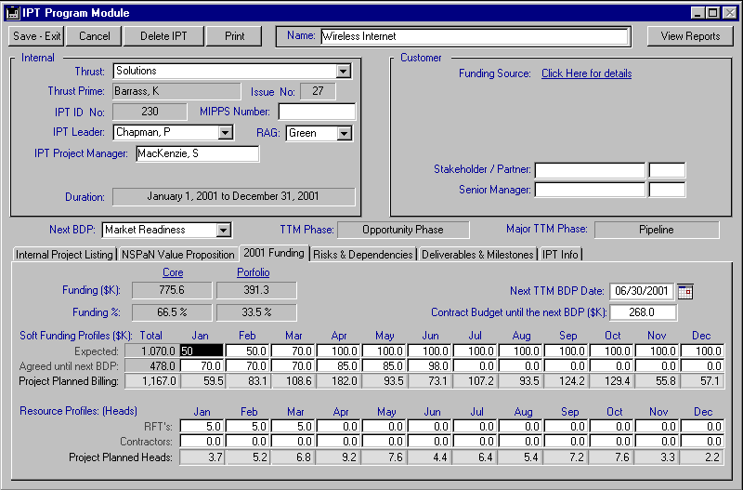
IPT Module | IPT Input screens have fields to capture key IPT and Thrust data, track heads and $. Contract screen at IPT level totals projects.  (Key Thrust, IPT Type, Status, PU No, Ref No, Sales, Duration (calculated), Pillar -> customer info, IPT Description,  Value, Funding, Internal notes, Marketing.  Ability to link multiple Projects into IPTs. Ability to collect Projects into an IPT from IPT level.  Facilitates linkage of multiple Projects into IPT for IPT Leader marketing control/administration.  Provides key Pillar and Functional Organisation text and financial roll up reports for upper management review on a nightly basis.  Ability to drill down from IPT Screen and reports to all screens at Project level.  Ability to create Combinations of departments for reporting.  Automatic links to Web resources – Livelink, etc.

Project Management | 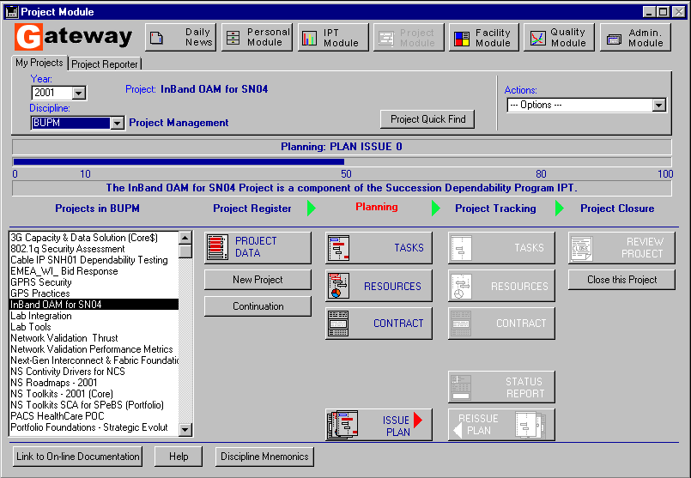
Project Module | Registering Projects, ability to clone existing Projects, ability to link to IPTs, Project Status: Speculative/Planning/Issued with ability to weigh by % probability. Assignment of Projects by function, by customer, by project type.  Linkages to customer database in Pillar loads customer hierarchy (– requires accurate customer data lists.)  Choice of Project Leader name defines location/region.  Fields: Status, Thrust, Functional Org, Functional Dept, Register Date, Functional Prime, Sales, Thrust Leader (auto), IPT Leader, Project Manager, Team Leader, (and departments auto), MIPPS No + Billed Issue No, (Finance only), Pillar choice fills customer fields. Most fields auto-filled from Pillar fields if project is linked to a IPT.  Provides ISO Compliant Business Process Control with issue and re-issue tracking/reviewing. Allows for complete project post-mortem reviews.  Sends automatic e-mails to upper management when specific Project actions are performed.  Set Project Cancelled and Set Project Completed wizards.
Task Planning - Tracking | Plan of Events -Planning/Tracking  Export/Import to MS Project  Activity-based Planning/Tracking capability with integrated issue control. Conforms to MPX format with multi-resource per task. Provides individual view of assigned Tasks for all Staff in NSPaN.  Provides repository of Best-In-Class task processes for insertion into Projects.  Enhanced resource load dialog allows resource to be found by skill, location, organisation, availability or name.
Project Status | Project Status Report Screen – Business Value, Highlights concerns, Executive Summary on Monthly basis. Milestones listing. RAG, Estimated Work Completed %. Can be printed for internal or external use.  IPT Status Report. Automatically rolled up from Project Status Reports.  IPT Module reports allow review of Status in listings.  Key Milestone and Deliverable tracking capabilities at planned, forecast and actual dates.  Project review option allows early project issue reviews

Resource Management | 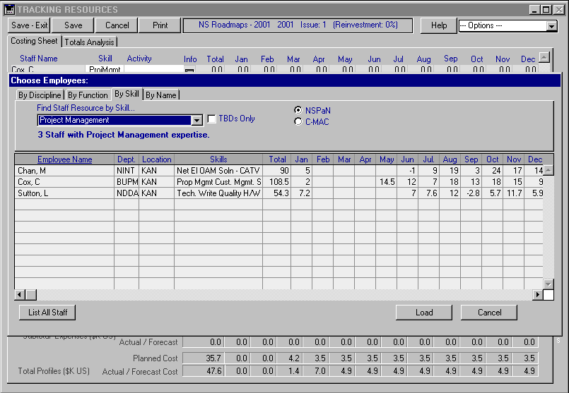
Personal Module | Personal Module – Register (LLC, Capacity, Location, Functional Org, CSD, DSD, Path, Skills, Program Org, e-mail, Manager’s name, OSM ID, Employee Position and Type.)  - Task Assignments  - Timesheet  - Resource Capacity - Loading  - Quality Recap  - Training tasks  Skills Inventory  Staff Allocation Wizard – Query tool that allows Resource Managers to view TBD (to be determined) resource allocations by Skill and find the best suited individual for the task.  Staff Utilisation Monitor – graphical load profiling tool that can be viewed at all levels of the organisation and drilled-down into individual load profiles and timesheet data.  Web Based Timesheet  Import Timesheets from Excel.  Admin Manager– Staff Library  Vacation tracking built-in.  Daily News Calendar: centralises communications from Gateway to personnel based on system-identified rules/anomalies.
Resource Planning - Tracking | Project Module - Plan of Resources for Speculative, Planning and Tracking phase projects.  Supports Staff and Facility Resource Planning/Booking/Tracking across all global locations.  Tracks Staff Resource Skills, and allows for optimal resource identification/utilisation across all NSPaN locations/organisations.  Monthly work profiles must be entered on a per resource basis per project. A notice will advise if a staff resource is overbooked.  Facility Module – Bookings/Details, Utilization screens  Personal Module – Timesheet/Assignments, Staff Utilization Monitor, Staff Allocation Wizard  Integrated Web Based time-sheeting system.  Supports flexible cost rates per individual resource in Resource libraries.  Enhanced resource load dialog allows resource to be found by skill, location, organisation, availability or name.  Staff Profile Utilities function allows enhanced editing of project staff profiles.  Provides reports to identify resource over and under utilisation.  Ability to assign TBD’s on project plans.
Facility Module | Booking Facilities, Splitting Bookings, Deleting Bookings. Maintaining up-to-date Booking info/costs ($k/day).  Facility Booking Browser, Project Booking Browser.  Displays visual representation of Facility Bookings.  Fields: Location, Manager, Category, Discipline, etc. upon facility creation.  Need to enter booking start and end date when booking a facility.  Nightly export to Web Reports system of Facility Resource Utilization data.

Contract Management | 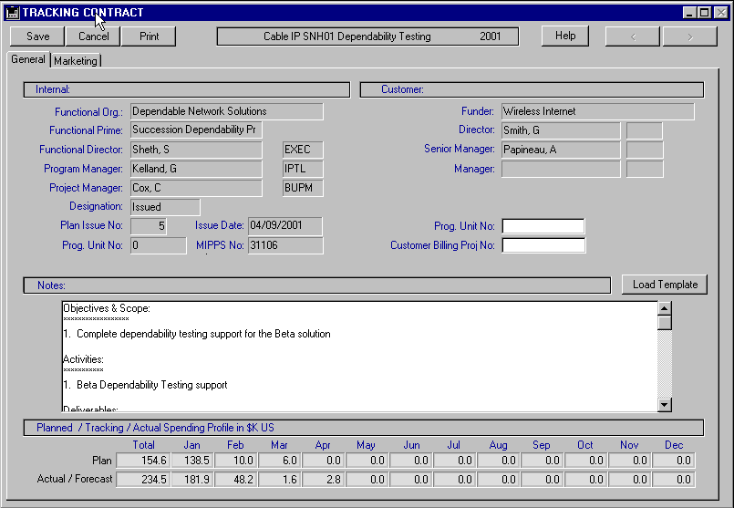
Contract Reporting - Cost and Billing | Supports early stage IPT entry with soft resource entry at IPT level and also in Speculative Project phase.  Supports speculative weighting of Projects as they progress through the Marketing lifecycle – Allows soft funding analysis and improved forecasting capabilities.  Supports user-defined Mark-up of Cost to set SCA Pricing. Provides reports and auto-emails to identify under-funded projects.  Fields required: MIPPS No, Issue reason, Sign off date, Signed By.  Customer Electronic signing on Web.  Built-in exports to LADS, MIPPS and User Pay for Financial System Integration.  Provides monthly Inter-PU resource usage reconciliation reports.

Administration
Quality Module | Corrective and Preventive Action Management  Integrated CA/PA Module.  Provides ISO issues management.
Admin Module | Administer Staff Lists.  Administer lists of expense/facility/choice lists. Runtime data field popup changes.  Administer replication when multi-server setup is in place.  User behaviour logging.  Auto-scheduled e-mails for timesheet submission.  Hosts Employee Opinion Survey web server.

Reporting | 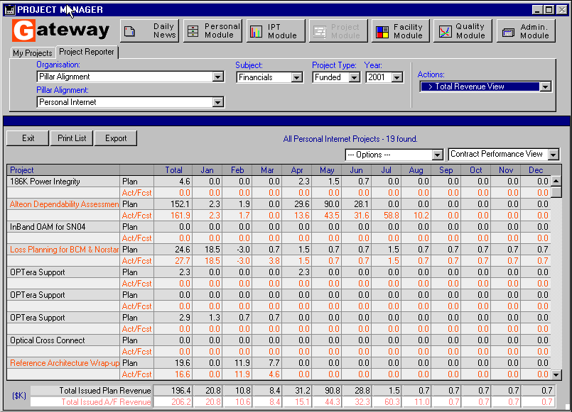

 |  | IPT  Module | Project Reporter | Personal Module
Real-time Reports | Project Commitment  Business Inventory  Project Status Compilation  Key Milestone Compilation  Executive Summary Compilation  Standard NSPaN Metrics Summary  Project Setting  Task Export  Contract Performance  Revenue Cost Performance  Total Revenue View  Reinvestment View  Business Summary View  Staff Revenue View  Facility Revenue View  Expense Revenue View  Interdepartmental Billing  Group Revenue Summary  Marketing Summary  Staff Loading  Staff Allocation  Demographics  Vacation View  Vacation Entitlement  Timesheet Usage Report  Interdepartmental Usage Export  TBD Export | X  X  X  X  X  X  X  X  X  X  X  X  X  X  X  X  X  X  X | X  X  X  X  X  X  X  X  X  X  X  X  X  X  X  X  X  X  X | X  X  X  X  X  X  X  X
Web Reports | Web Reports Interface- updated nightly  - 9 IPT Reports  - 15 Marketing Reports  - 8 Pillar Reports  - 7 Customer Reports  - 4 Financial Reports  - 16 Resource Utilization Reports  - 2 Miscellaneous Reports  - - 5 System Utilization Reports

Technical
Modularity | 7 Modules – Daily News, Personal, IPT, Project, Admin, Quality, Facility Modules.
Licensing Fee Structure | Gateway licence fee – Please contact Nufocus Inc. Also available on rental basis. support@nufocusinc.com  4D Server costs based on per concurrent client login. In a typical R&D environment, a concurrent user licence effectively services 10 users. - Much more cost-effective than “per-seat” fee structures.
Web Capability | Web Capable.  Customer Electronic Signing and Timesheet on Web implemented.
Cost –Server Software | Concurrent client user. Please contact Nufocus Inc. support@nufocusinc.com  Server application installation and setup. Please contact Nufocus Inc. support@nufocusinc.com
User Interface | Rich, user-friendly, multi-platform, ODBC-compliant. Use of web access when appropriate.
Deployment Support | Web-based deployment, User Manual and Tech Notes.  Presently replicating between 2 servers (Kanata, Harlow)  Also deployed using thin-client technology for optimum WAN support for remote sites/users.
Maintenance Requirements | Admin Manager – 5-10% load on a single Admin staff member.
Interface/Interlinking Capability | ORACLE, ODBC  Web  LiveLink, Business Objects capable.  Text Export/Import capabilities.  MPX Import/Export  MS Office – Excel, Word  Executive Dashboard system integrated with Cognos PowerPlay
Platform Support | Windows NT/Windows 2000/Windows 95/Macintosh
Internal/External Compatibility | ODBC/JDBC compliant.  Project Management compatible with MPX (MS Project, AutoPlan…)  Data exports are launched to MS Word and Excel as required.  Netscape/Internet Explorer launch capability built-in.  Ad-hoc search, sort, report, export editors built-in.  Complete Help system via Web.
External Vendor Assessment | 4D Inc. – Proven relational database platform. Established 1985.  Cost effective solution: http://www.4d.com/products/tco/aberdeen_2001.html

