Gateway – Enterprise Management System

Product Description
Gateway is an integrated, pre-packaged solution for effective management of services and resources within a highly dynamic, knowledge-based, IP focused organization.
Gateway integrates an end-to-end view of the business, enables faster, better, and more informed business decisions and extends analytical capabilities to more users at all levels of an organization.
Serving locations throughout North America and the UK, Gateway’s Staff, Facility and Knowledge libraries centralize resource control, optimize resource expertise allocation and maximize resource utilization across a geographically disperse organisation.
Designed to promote intra-organisation collaboration and communication, Gateway is providing a single access point for all personnel to track and collect all information pertaining to the delivery of Products and Services to both internal and outside customers.
Gateway – Architecture
Gateway services the needs of all levels of an organization:
- Senior management are served with timely and accurate project status, marketing and financial reports.
- Program Managers can view reports for program analysis, resource utilization, and milestone reviews. Web-based reports consolidate data from across the complete organisation, regardless of geographic location, functional organisation or business focus.
- Marketing Staff can consolidate hundreds of projects and evaluate margins and revenues in real-time.
- Project Managers can track resources within individual projects or across many projects, while quickly tracking the technical and/or cost situation.
- Resource Managers can optimize resource utilization using tools specifically designed to pinpoint resource anomalies. Charts and spreadsheets are available to quickly identify problems and subsequently analyze for solution.
- Individual engineering/technical staff members can view any tasks assigned to them, monitor/edit these tasks, update their timesheet, and view their contribution to the organisations’ Quality efforts from a single screen.
- Financial staff are served with accurate reports and data exports for corporate financial system entry.
- System generated auto-E-mail notification is used at various points in the project life-cycle to apprise management of potential anomalies and exceptions in project data.
- An embedded corrective and preventive action tracking system provides an ISO-compliant environment for quality adherence and improvement.
- Gateway can be configured easily to a new organization’s environment. Choice lists throughout Gateway are data-driven, and can be quickly edited in the Gateway Admin Module. Company re-organizations are seamlessly implemented via the Gateway Admin Module.
Gateway produces all required documentation throughout a project’s lifecycle. Professional-quality reports and contract forms can be printed or electronically delivered to our customers.
Gateway – Enterprise Management System
Sample Screens
To create a new Project on Gateway a user simply initiates a new Project and assigns the Internal and Customer information. Functions to clone complete Project plans from existing projects and libraries of best-in-class processes are available, providing rapid entry and sustained high quality project standards.

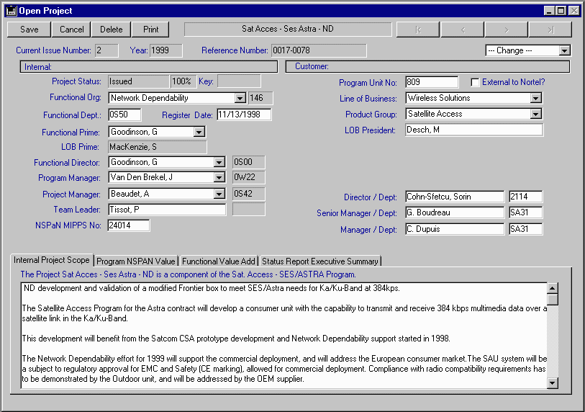
Project Register: To create a new Project on Gateway a user simply initiates a new Project and assigns the Internal and Customer information. Functions to clone complete Project plans from existing projects and libraries of best-in-class processes are available, providing rapid entry and sustained high quality project standards.
Task Planning/Tracking: Task Plans allow the Project Manager to perform task leveling and resource allocation for resources across the organisation. Task Plans can be quickly built by cloning from existing projects, downloading Task Plans from a process library, building from scratch, or importing from MPX compliant tools such as Microsoft Project.

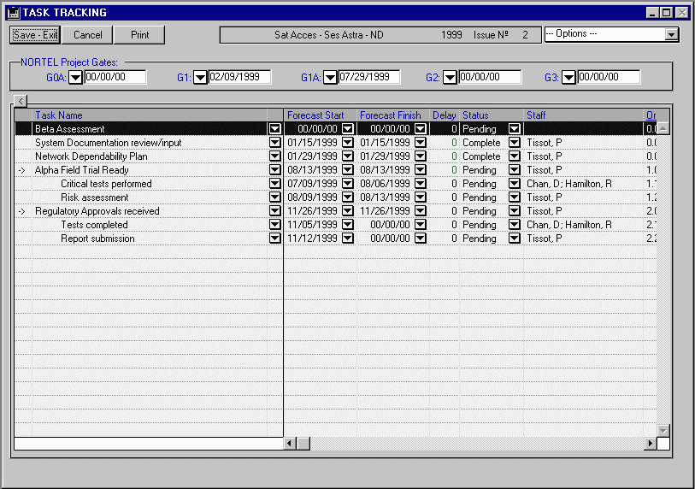
Resource Plans are tracked and amended by project managers. Costs are immediately visible, and deviation from the billed contract profile is immediately apparent. Gateway follows an ISO compliant Issue/Reissue approach to project management, allowing valuable post-mortem analysis of all prev.
Resource Planning/Tracking: Resource Plans are tracked and amended by project managers. Costs are immediately visible, and deviation from the billed contract profile is immediately apparent. Gateway follows an ISO compliant Issue/Reissue approach to project management, allowing valuable post-mortem analysis of all previous project issues as required.

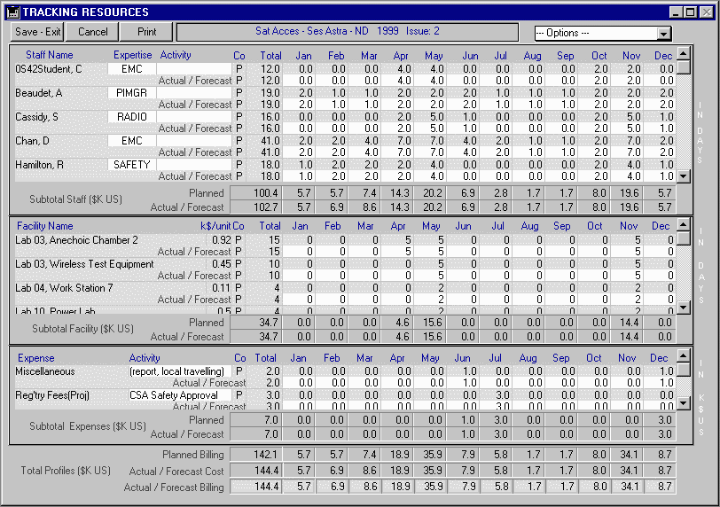

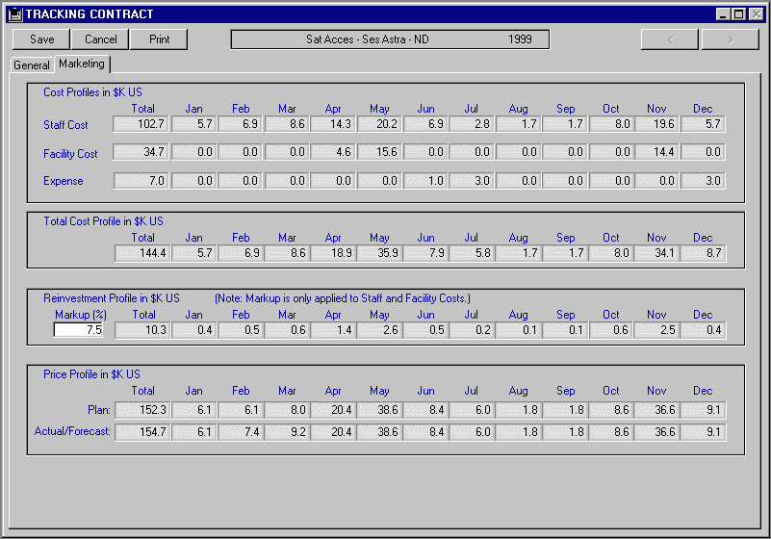
Project Financial Performance: Marketing staff can track hundreds of projects’ performance from a single screen and then immediately take action by amending the pricing profile. Contract Price profiles for all projects in Gateway can be viewed from a single web page or internal screen. Individual customer and internal functional organisation cost, price and margin totals are tracked in real-time for immediate review.
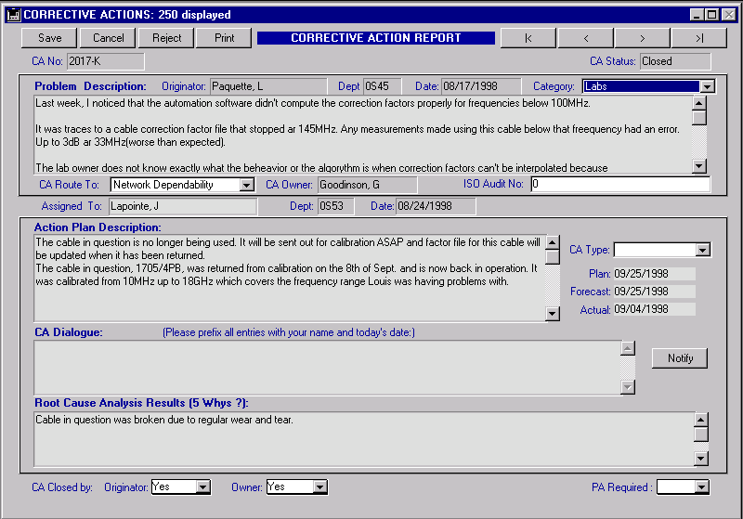
Quality Module: Gateway includes a full-function Quality management tool that tracks corrective and/or preventive action issues within the organisation. Routing control, assignment to experts and closure control are offered in an easy-to-use environment. System generated updates to concerned parties track the progress through the stages of addressing a quality issue.

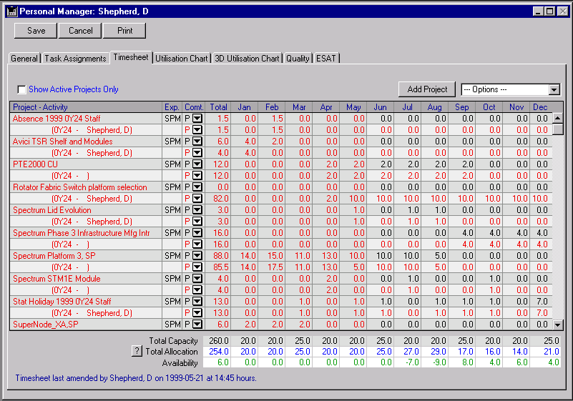
Personal Module: Individual staff members can track and manage their project, task, quality and employee satisfaction issues from one screen. Graphical representations of workload and timesheet edit and submission are easily monitored. Tasks assigned to this person can be filtered for overdue, incomplete or pending status. The timesheet screen automatically updates resource availability and contribution to the component project’s cost lines.

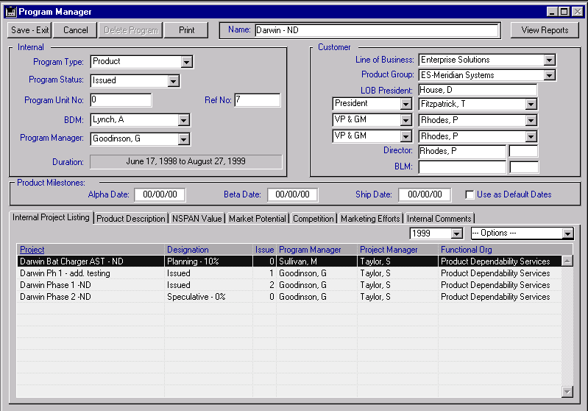
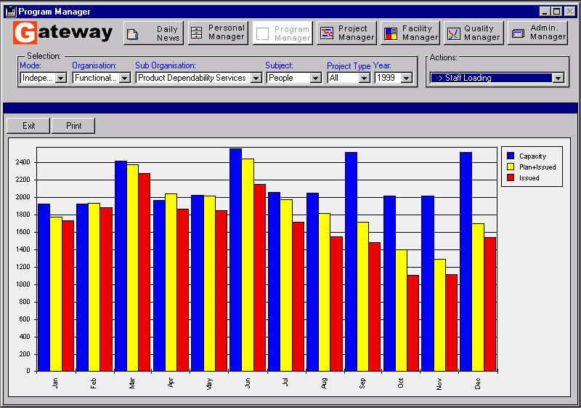
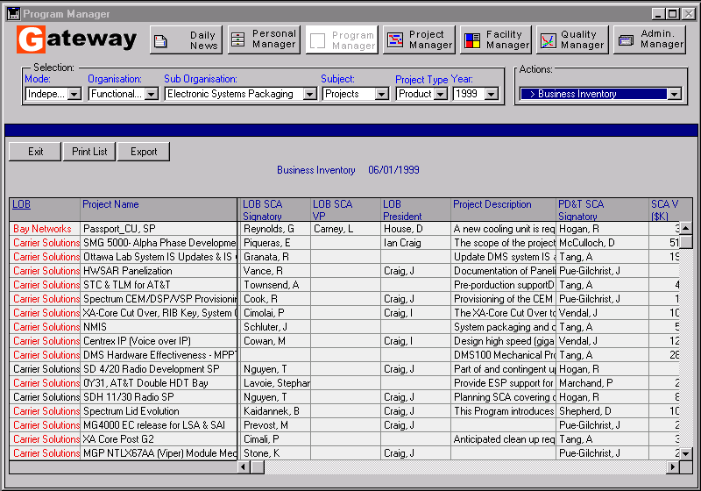
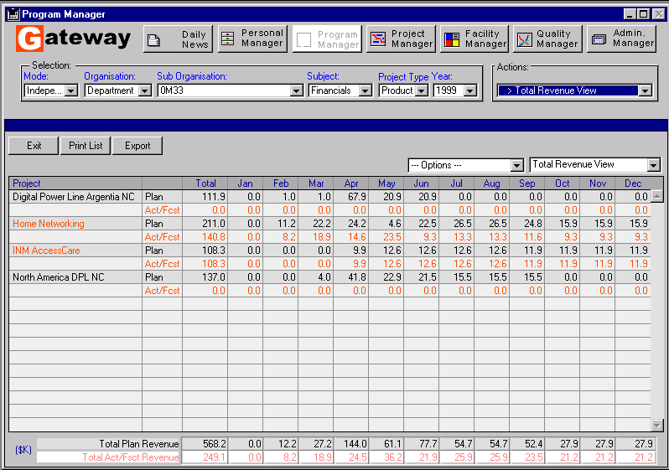
Program Module: Gateway offers the ability to track projects by customer or functional organisation or by creating discrete Programs to collect several projects. This environment allows large-scale Programs to be monitored and invoiced without affecting the operation of the underlying projects. Reports monitoring project technical, resource and financial status plus powerful exports can be viewed for any collection of projects.

Financial Reports: Cost, Price and Reinvestment summaries can be viewed as real-time roll-ups of any collection of projects. Numerous analysis and totals formats are available to aid in the monitoring of a project’s financial performance. Charts displaying YTD performance and month-by-month fiscal indicators are available. Projects displaying poor indicators can be “drilled-down” and evaluated from all financial report screens.

Resource Reports: Staff resource charts and allocation listings are easily displayed without any customization. Exports to spreadsheets and charting tools can be used to enhance analysis.

Project Reports: Project specific reports such as Business Inventories, Gate date reports, milestone and deliverable summaries are easily viewed on-screen. A custom report editor is also available that allows users to create printed reports or exported data dumps of Gateway data. Gateway is ODBC-compliant and can be used as a data source for any ODBC-compliant reporting tool.

